Foldable Directions:
- Make a foldable as shown below:
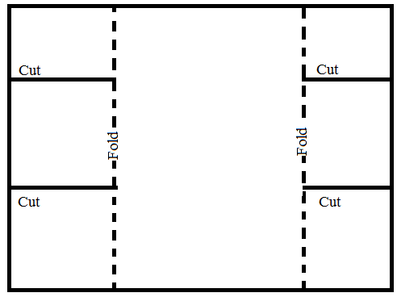
- Label the Outside Flaps with the names of Scientists that have contributed to the atomic model:
  - Dalton
  - Thompson
  - Rutherford
  - Bohr
  - Cloud
  - Title, Name, Class Period
- Inside Flaps
  - Contribution (What is it)
  - How they arrived at that idea (Ex: Gold Foil/student of/etc…)
  - Picture of atomic model
  - Comparison (Ex: Watermelon)
- Big Center
  - Modern Atomic Model
    - What is it?
    - Draw picture with Labels

