Periodic Table Coloring
Name: _________________ Date: ________ Period: ________
Color-code the periodic table below. You can choose the color to use for each category. Make sure to color the table neat enough so you can distinguish between the different groups.
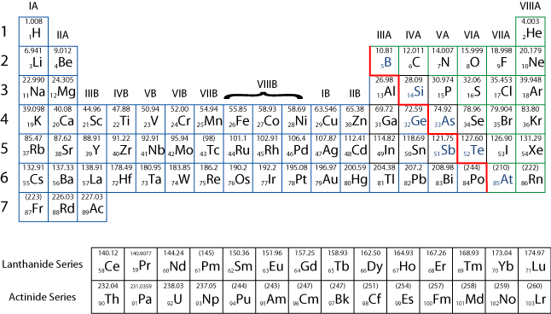
Key:

